3.69: Take 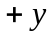 to be upward.
a) The vertical motion of the shell is unaffected by the horizontal motion of the tank. Use the vertical motion of the shell to find the time the shell is in the air:
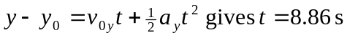
Relative to tank #1 the shell has a constant horizontal velocity 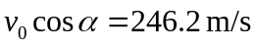. Relative to the ground the horizontal velocity component is 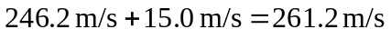. Relative to tank #2 the shell has horizontal velocity component 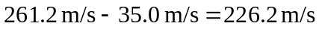. The distance between the tanks when the shell was fired is the 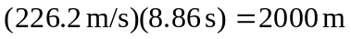 that the shell travels relative to tank #2 during the 8.86 s that the shell is in the air.
b) The tanks are initially 2000 m apart. In 8.86 s tank #1 travels 133 m and tank #2 travels 310 m, in the same direction. Therefore, their separation increases by 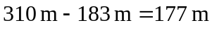. So, the separation becomes 2180 m (rounding to 3 significant figures).

